We are inviting you to take part in a research study called:
Identifying the best ways to deliver health care for people from ethnic minority groups living with chronic obstructive pulmonary disease (COPD) and other health conditions.
- Are you from an ethnic minority group?
- Are you living with COPD and another health condition?
- Have you had an offer of a consultation about your condition using telephone, mobile phone, app, video-link or website?

If yes to all three questions, we would like to hear your views and experiences of the health care you might have received in a one-to-one interview.

We hope this study will help us to improve the experiences of health care by remote delivery for people with COPD that is suitable and acceptable to them.

If you are interested in taking part in the study, please contact the study researcher:
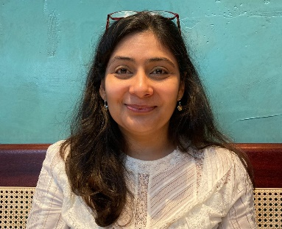
Study researcher: Dr Ratna Sohanpal
Contact details: Centre for Primary Care, Queen Mary University of London, 58 Turner Street, London, E1 2AB. ratna.sohanpal@nhs.net, 079 3929 6667
Please note: Speaking to us about the research study does not commit you to anything, we will be happy to answer questions and you can decide if taking part in the study is right for you.

