Centre for Primary Care, Wolfson Institute of Population Health
Queen Mary University of London
Yvonne Carter Building
58 Turner Street, London, E1 2AB

COPD and Assistive technology
Study title: Understanding the potential of assistive technology (AT) in people with chronic obstructive pulmonary disease (COPD) to support independence and wellbeing: A qualitative study
Research Ethics Committee Ref: Ref: 23/LO/0660

Participant information sheet (Professionals)

You are invited to take part in the COPD and Assistive technology research study. Before you decide whether or not you wish to take part, it is important for you to understand why the research is being done and what it will involve. Please take time to read the following information carefully and discuss it with others if you wish. Ask us if there is anything that is not clear or if you would like more information.

1. What is the purpose of the study?
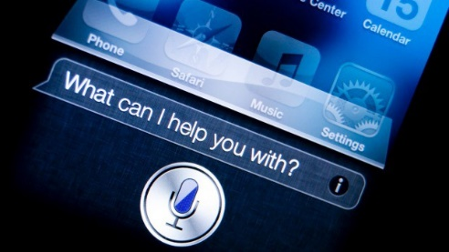
Assistive technology (AT) comprising home modifications, digital technology or innovative digital infrastructure solutions is being given priority by the UK government as a cost-effective way of supporting independence, health and wellbeing for people living with disability or long-term conditions. People with COPD have highlighted the need for AT to support independent living at home, however the evidence to support implementation of AT is lacking.
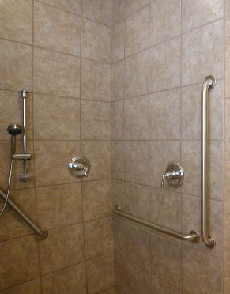

We would like to hear your views, opinions and insights on this topic. In a one-off interview with the study researcher (Farhin), the discussion will be to understand your experience in AT service provision (i.e., whether in commissioning, referral, assessment, supplier/retailer, service provider, designer). We would like to understand what works, what are the challenges, and what and how improvements might be made.

2. Why have I been invited to take part?
You have been invited to participate in the study as you are a health or social care professional, or you are working in health and social care and might be involved in AT service provision to support independent living at home among people living with COPD/people living with long-term conditions. You may have experience (or interest or may be supportive of or not) of provision of assistive technology.

3. What are the possible benefits of taking part?
There might be no direct benefits to you taking part in the study, but your contribution could help in identifying ways of improving availability, accessibility of assistive technology to people with COPD in need that is acceptable, appropriate and timely to them.
4. What are the risks or disadvantages of taking part?
We do not foresee any risks if you decide to take part in the study.

5. What will happen if I decide to take part in the study?
If you decide to take part, Farhin will suggest some dates and time and arrange a date and time that is convenient to you for the interview. The interview will take place at your preferred location, and this could be by telephone or online (example MS Teams or Zoom) or face-to-face (e.g., in your office and in line with national and local Covid guidance). Farhin will arrange your travel if necessary.

Farhin will take your written permission before the start of the interview. It will last up to one hour and will be audio-recorded. You will be able to take a break at any time if you need to. The recording will be typed up in full by a confidential third-party transcription service contracted to work on the study. The secure transfer of the recording and the typed document between the study team and the transcription service will be done by secure email transfer or by using the Royal Mail Signed for Special Delivery Service. The recording or the typed document will not be heard or seen by anyone other than the study team and the study transcriber and will be kept securely. You may listen to the recording or read the document if you wish to do so.

As a thank you for your time and contribution to the study, we will offer you a love2shop voucher (£30 voucher. The amount is based on the hourly rate of professionals set by clinical research network to support their involvement in research activity).

The study duration is of 15months. If you would like to hear about the progress of the study, we will provide updates by post or email as per your preference.

6. Do I have to take part in the study?
No. It is up to you to decide whether you wish to take part. If you decide to take part, please inform Farhin. You are free to withdraw from the study at any time and without giving a reason and this will not affect any of your rights. If you decide to withdraw after the interview, the study sponsor (Queen Mary University of London) will retain any information about you that has already been provided in the anonymised form (you will not be identifiable in any way). Any personal contact details will not be retained and will be deleted.

Please be aware that if you are taking part in research, or information about you is used for research, your rights to access, change or move information about you are limited under the UK General Data Protection Regulation. https://www.hra.nhs.uk/information-about-patients

7. How will we use information about you?
We will need to use information from you for this research project. This information will include your contact details held by the study team to arrange the interview.
People who do not need to know who you are will not be able to see your name or contact details. Your data will have a code number instead. We will keep all information about you safe and secure.
Once we have finished the study, we will keep the data to write the study results and study reports, and this will include use of direct quotations. We also plan to produce various outputs in the form of study summary report for you, presentations (or short videos or blogs or in conferences) and journal publications in a way that no-one can work out that you took part in the study.

The information collected from this interview may be used to support other research in the future and if so, the information will be shared in anonymised form with other researchers.

The data collected during the study, may be looked at by individuals from Queen Mary University of London or regulatory authorities where it is relevant to your taking part in this research. We will ask your permission for these individuals to have access to your records.

8. What are your choices about how your information is used?
- You can stop being part of the study at any time, without giving a reason, but we will keep information about you that we already have.
- We need to manage your records in specific ways for the research to be reliable. This means that we won’t be able to let you change the data we hold about you.

You can find out more about how we use your information by sending an email to [ratna.sohanpal@nhs.net], by ringing us on [079 39 29 6667] or by sending email to the QMUL data protection team: data-protection@qmul.ac.uk

9. When and how long will my information be stored for?
At the end of the study (30 September 2024) the audio-recording will be destroyed. The anonymous typed document will be stored for 5 years in line with the study sponsor regulations and guidance.

10. Who has reviewed the study?
This study has been reviewed by an independent NHS research ethics committee and approved by Research Ethics Committee. The reference number is 23/LO/0660.

11. What should I do if I have any concerns about this study?
Queen Mary University of London has insurance to protect research study participants. Your wellbeing will always be our priority. We believe that this study is safe and do not expect you to suffer any harm or injury because of your participation. However, Queen Mary University of London has agreed that if you are harmed as a result of your participation in the study, you will be compensated. In such a situation, you will not have to prove that the harm or injury which affects you is anyone’s fault. These special compensation arrangements apply where harm is caused to you that would not have occurred if you had not taken part in the study. These arrangements do not affect your rights to pursue a claim through legal action.

For independent advice and support, you can contact the NHS Patient Advice and Liaison Service:
The Royal London & Mile End Hospitals - 0203 594 2040 RLHpals.bartshealth@nhs.net
Whipps Cross Hospital - 0208 535 6438 WXpals.bartshealth@nhs.net
Newham University Hospital - 0207 363 9292 nuhpals.bartshealth@nhs.net
St Bartholomew's Hospital - 0203 465 5919 SBHpals.bartshealth@nhs.net

12. Who can I contact if I have any questions about this study?
You can contact:
Farhin Ahmed (study researcher) farhin.ahmed@qmul.ac.uk 07940422954 Centre for Primary Care, Queen Mary University of London, 58 Turner Street, London, E1 2AB.

Dr Ratna Sohanpal (study lead) ratna.sohanpal@nhs.net 07940422954 Centre for Primary Care, Queen Mary University of London, 58 Turner Street, London, E1 2AB.

Thank you for taking the time to read this information.

