**White, Black, Indian, Pakistani, Bangladeshi patients with COPD/carers of patients with COPD to take part in a research study**

**UNDERSTANDING THE POTENTIAL OF ASSISTIVE TECHNOLOGY (AT) IN PEOPLE WITH CHRONIC OBSTRUCTIVE PULMONARY DISEASE (COPD) TO SUPPORT INDEPENDENCE AND WELLBEING.**

**We are interested if you have used:**

**Electronic technology e.g., *Personal alarms\***

**Home adaptations e.g., *Stair lifts\***

**Digital technology e.g., *Alexa\***

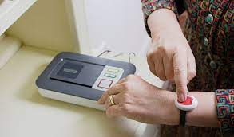

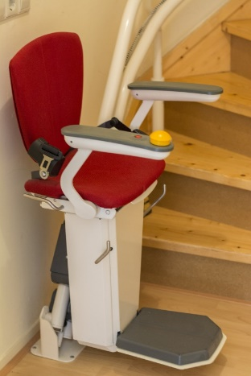



**We wish to find out in a one-to-one interview what you have used, what’s helped and what’s not helped.**

**For informal, no obligation chat please contact:**

|  |
| --- |
| **Study researcher**  **Priya AHMED | PhD Health Psychology Student | Master of Science | Teesside  University, Middlesbrough | School of Social Sciences, Humanities & Law |  Research profileFarhin Ahmed**  [farhin.ahmed@qmul.ac.uk](mailto:farhin.ahmed@qmul.ac.uk) 07940422954  Centre for Primary Care, Queen Mary University of London, 58 Turner Street, London, E1 2AB. |

**Please note: Speaking to us about the research study does not commit you to anything, we will be happy to answer questions and you can decide if taking part in the study is right for you.**