Example protocol:
Recall for 8 week check
and childhood immunisations

Shared with kind permission of The Old Church Surgery, Waltham Forest. Different practices will have different procedures in place, but we hope this example will help others establish a protocol that works for them.

Invite for post-natal, 6-8 week baby check and first immunisations
Responsibility: Patient Liaison Manager and Practice Nurse

- Scan new baby discharge letters on receipt and retain a hard copy of the document in a folder in reception.
- Run the CEG APL-Imms childhood immunisation tool on weekly basis. This tool is located in the shared drive, in the Practice Admin Folder > Child Imms
- Use the tool to show a list of newly registered babies by selecting the Age Band filter <8 weeks:

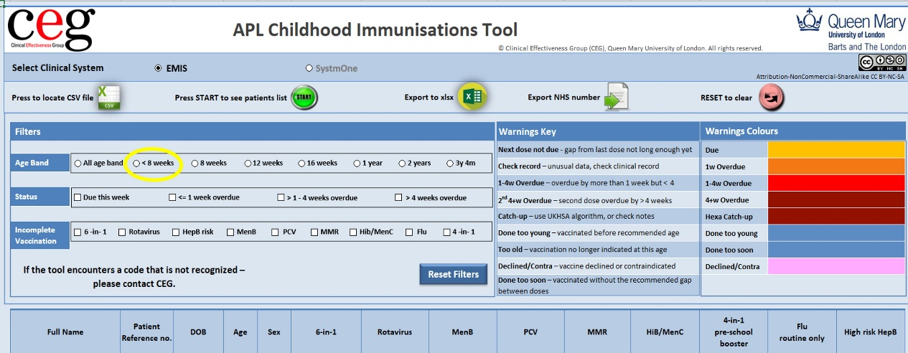

- The Patient Liaison Manager (PLM) will check this search against the hardcopy discharge letters to ensure all newly born babies are listed in the tool.
- For babies not appearing in the list, the PLM will check EMIS to confirm the baby has been registered. If there is no registration when the baby is 4 weeks old, the PLM will contact the parent of the child to remind them to register their baby with the practice.
- Once the baby is registered, the PLM can securely dispose of the hardcopy birth discharge letter.
- Once a baby reaches 4-6 weeks of age, the PLM will invite the baby and mother to attend an appointment with the doctor for their 8-week check and post-natal check respectively, and book an appointment with the practice nurse for baby’s first immunisation.

This should be an ongoing process and should be checked weekly to ensure all new babies are formally registered with the practice.
Registrations can be processed via the practice website or by the parent attending the practice in person to complete the appropriate forms. Online registrations should be encouraged as much as possible.

- During the first immunisation appointment, the Practice Nurse should offer an appointment for next vaccination.
- The Practice Nurse should ensure that the CEG template (Childhood Immunisations CEG RP) is always used when vaccinations are given. The same template should be used to record missed appointments, contraindications and any past immunisations that are not already recorded.

Call and recall for routine childhood vaccinations
Responsibility: Administrator
On a weekly basis, a member of the administration team will rerun the EMIS search and import it into the CEG APL-Imms tool. (Refer to CEG’s User Guide and demo videos for full details of how to use this tool). Use the tool to identify children who need to be recalled:

- Due for vaccination - This filter will identify children due for imminent vaccination.
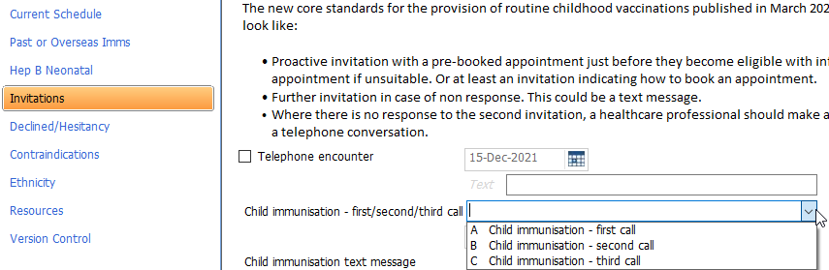
The administrator should check whether an appointment has already been scheduled. If there is no appointment, the administrator should contact the parent of the child by telephone and book an appointment as soon as possible. Administrators should ensure they record the invite on the Invitations page of the CEG template (Childhood immunisations CEG RP).

- 1 week overdue - This filter should identify any recent DNAs, cancellations, newly registered children, and those children slightly overdue vaccination.
The administrator should check whether an appointment has already been scheduled. If there is no appointment, the administrator should contact the parent of the child by telephone and book an appointment as soon as possible. Administrators should ensure that they record the invite on the CEG template (Childhood immunisations CEG RP)

- >1 - 4 weeks overdue - This filter will identify children who are overdue vaccination by more than one week but less than five weeks.
The administrator should check whether an appointment has already been scheduled or whether there is a known reason for the delay in the child receiving the vaccination, e.g. previous cancellation, child on holiday, etc.
Following a review of the child’s records, the administrator should try to book another appointment for the child or if in any doubt, the administrator should discuss the situation with one of the Practice Nurses.

- >4 weeks overdue – this filter will identify children who are significantly overdue for their vaccinations.
The APL-Imms tool should be used to identify these children on a monthly basis.
The administrator should check whether an appointment has already been scheduled or whether there is a known reason for the delay in the child receiving the vaccination. e.g., previous cancellation, child on holiday, etc.
Please note:
- At this stage, there is likely to be a reason why the vaccination has not been given. There may be a variety of reasons and children on these lists should be investigated by reviewing the EMIS medical record. This is likely to be free text rather than coded information.
- It may be sensible to keep a baseline list of children, so it is easier to see which children have been investigated previously (and do not need to be further investigated) and which children are ‘new’ to the list.
- Contractually, practices should ensure all children due vaccination receive a minimum of three invites, and one of these invites should be from a clinician.
- Due to the large number of patients likely to show in this list and the fact that overdue children do not ‘drop off’ this list until their sixth birthday, it may be sensible to identify children for investigation by using the age filters one at a time - 8 weeks, 12 weeks, 16 weeks and 1 year. At this stage, we will not review children in the 3 years 4 months category as these children will be reviewed separately.

Version 1.0 – March 2022

