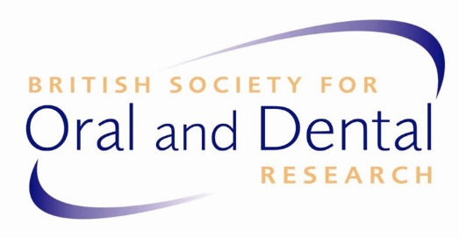

D

BRITISH SOCIETY FOR ORAL AND DENTAL RESEARCH

ANNUAL BUSINESS MEETING 2023

16:30 Thursday 7th September 2023, Skeel Lecture Theatre Peoples’ Palace
Queen Mary University of London, Mile End Road, London E1 4NS

AGENDA

- Apologies for absence

- Declarations of other business

- Minutes of ABM 2022 held: 16th September 2022 at PER Marseille(attached)

- Matters arising from the previous minutes

- President’s report
- Secretary’s report, including formal notification of the election of BSODR Management Committee members
- Treasurer’s report
- Editors report
- Councillor ECR report
- Webmaster’s report
- Chair of the awards committee
- AOB and dates of next meeting

  - BSODR 2024 Annual Meeting: Newcastle (Chris Nile)
  - IADR/PER/BSODR 2025
  - Future BSODR Annual Meetings (Paul Anderson)

