Entering Your Academic Teaching Qualifications on MyHR

The Higher Education Statistics Agency (HESA) requires higher education institutions to record whether our academic staff hold a higher education teaching qualification, another relevant teaching qualification, or have been recognised in other ways for their teaching expertise. This information is sent to HESA every year.

Please use this form to record information about your Fellowship of the Higher Education Academy as well as your teaching qualifications (eg PGCE).

What should I do?

If you are not an academic member of staff, this does not apply to you and you do not have to do anything.

If you are an academic member of staff, you will need to complete one or more of the drop‐down fields on the MyHR questionnaire.

How to complete the MyHR questionnaire

- Log onto MyHR as usual.

- Once you have access, select ‘HESA Data Collection’ from the menu on the left-hand side of the screen.

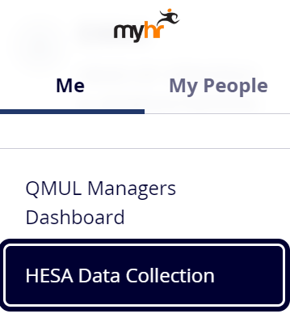

3) Select ‘Academic teaching qual questionnaire’ from the drop-down list and select ‘Complete Form’.

- Clicking on [Complete Form] will take you into the Teaching Qualification and Recognition questionnaire.
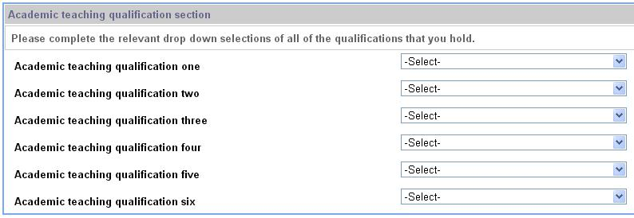

There are six drop-down menus, all with the same values behind them. This is because you can list up to six different academic teaching qualifications that you may hold.

- Select from the drop down labelled “qualification one” the relevant recognition or qualification you hold (refer to Appendix One for a full list and full descriptions from HESA).
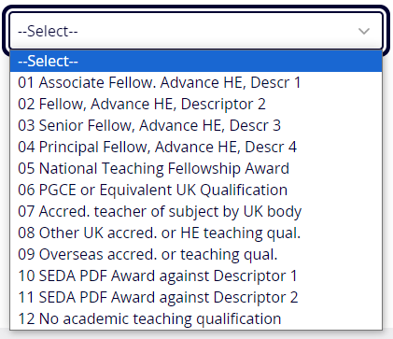

If you hold none, please select “12 No qualification held”.

If you hold more than one form of recognition or qualification, please repeat this process for the other drop-down menus.

Note: You only need to select from each drop-down menu if you have a qualification to list. For example if you hold two academic teaching qualifications, you only need to select from drop down lists one and two.

- To submit the questionnaire once you are done, please click on [Submit] in the bottom right hand corner of the screen.

Once you click on [Submit] you will get a confirmation message

Click [Continue] in the bottom right hand corner to go back to MyHR front page.

Amending Your Completed Questionnaire

To view the data you have selected from the drop-down menus, you need to go back into the HESA Data Collection page and you will see a screen showing your completed questionnaires. The title of the questionnaire is a link. To go back into it, click on this link:
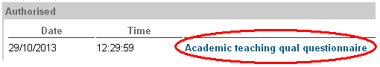

If you want to amend the questionnaire data, you should submit a new form, as per instructions above.

If you have submitted a new questionnaire, you will be able to view both the old and new form on your Questionnaire screen as such:
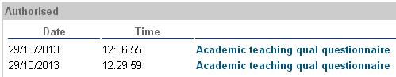

Your most recent entry will always be considered your final, valid entry.

Appendix One – HESA Academic Teaching Qualification Codes
Code | Label
1 | Successfully completed an institutional provision in teaching in the higher education sector accredited against the UK Professional Standards Framework
6 | Holder of a National Teaching Fellowship Scheme Individual Award
7 | Holder of a PGCE in higher education, secondary education, further education, life long learning or any other equivalent UK qualification
8 | Accredited as a teacher of their subject by a professional UK body
9 | Other UK accreditation or qualification in teaching in the higher education sector
10 | Overseas accreditation or qualification for any level of teaching
11 | Recognised by Advance HE as an Associate Fellow against Descriptor 1 of the UKPSF
12 | Recognised by Advance HE as a Fellow against Descriptor 2 of the UKPSF
13 | Recognised by Advance HE as a Senior Fellow against Descriptor 3 of the UKPSF
14 | Recognised by Advance HE as a Principal Fellow against Descriptor 4 of the UKPSF
15 | Recognised by SEDA against Descriptor 1 of the UKPSF
16 | Recognised by SEDA against Descriptor 2 of the UKPSF
90 | Not known
99 | No academic teaching qualification held

Appendix Two – HESA Notes on Academic Teaching Qualifications Collection

This information is taken from the HESA website and relates to the 2023/24 data collection.

There is no implied hierarchy in the valid entries, neither is there any implied equivalence. Only qualifications for teaching in higher education should be returned in this field, other qualifications are not considered to be a teaching qualification. For new members of staff in the 2022/23 collection valid entry code 01 should not be returned.

Valid entry code 01
Courses recognised by SEDA against its Named Awards that are accredited against the UKPSF (Supporting Learning; Learning Teaching and Assessing) can be coded as 01 as in previous years for continuity or can be mapped to the new valid entry codes 15 and 16.

Qualifications that predate the UK Professional Standards Framework (UKPSF) should also be coded 01.

The valid entry code 01 has been included this year for continuity. However, we will look to discontinue code 01 in future years, therefore any staff previously returned under the 2018-19 valid entry '01 Successfully completed an institutional provision in teaching in the higher education sector accredited against the UK Professional Standards Framework', who do not fall into the new codes for 2019-20 of 11, 12, 13, 14, 15 or 16, or where a staff member attends an accredited course that leads to an award, but has not gone forward for the accreditation, should be returned under valid entry code 09.

Valid entry code 06
Higher education providers (HEPs) should return valid entry code 06 for staff who have been recognised by Advance HE (or previously the Higher Education Academy) at any time.

Valid entry code 07
The following items should be coded 07:

Qualifications that lead to QTS that are not PGCE.
Diploma in Teaching in the Lifelong Learning Sector (DTLLS).
Diploma in Education and Training.
Valid entry code 09
HEPs considering the return of valid entry code 09 because it is believed the current list does not incorporate a UK accreditation or qualification held by a member of staff, please contact Liaison in the first instance.

Valid entry code 10
Where overseas accreditation and qualifications are achieved at any level code as 10.

Valid entry codes 11-14
Examples of Advance HE awards include:

- Associate Fellow - code 11
- Fellow - code 12
- Senior Fellow - code 13
- Principal Fellow - code 14

An individual can only hold one of the awards accredited against valid entry codes 11, 12, 13, and 14 at a given point in time.

Higher education providers (HEPs) should return valid entry code 06 for staff who have been recognised by Advance HE (or previously the Higher Education Academy) at any time.

Please contact Advance HE via FellowshipTeam@Advance-HE.ac.uk to obtain data on individuals recognised as Fellows (valid entry codes 11, 12, 13 and 14), or a National Teaching Fellow (valid entry code 06), that are currently recorded as employed at your organisation.

Valid entry codes 15 and 16
Examples of SEDA awards:

Supporting Learning has been mapped to Descriptor 1, therefore return code 15
Learning, Teaching, and Assessing to Descriptor 2, therefore return code 16
Please note that this alignment and its recording are quite separate from the use of the UKPSF made by Advance HE to accredit programmes to award Advance HE fellowships.

City and Guilds teaching qualifications should be coded either to 09 or to 07, where the qualification is equivalent and leads to Qualified Teacher Status (QTS).

It is important that what is returned in this field is up to date, to reflect any qualification changes while a member of staff is in their current post, and that the HEP does not rely on the information provided upon appointment.

For the purposes of this field, any Teaching English as a Foreign Language qualification should be returned as valid entry code 99.

