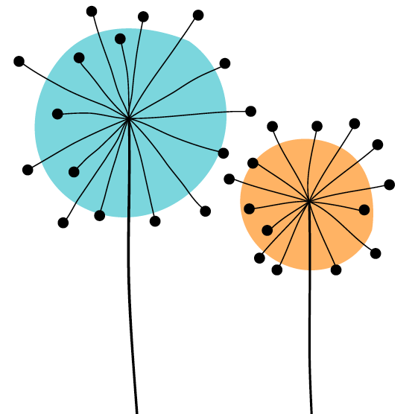

Queen Mary Academy
Student Enhanced Engagement & Development (SEED) Award
Application Form

Before completing this application form, students are reminded to carefully consider the Student Guidance Document and the SEED training video. It is important to remember that in the context of this SEED Award, ‘student engagement’ relates to student partnership with educators aimed at co-creating and enhancing the student learning environment, all of which adds meaningful change to the overall quality of the student learning experience. This aim may be achieved in many different ways, some of which are outlined in more detail in the Student Guidance Document, but they always consider co-creation in terms of collaborative work on the curriculum, course documentation, and the diversity of educational tasks across the discipline areas.

The criteria of the SEED Award are outlined on page 4 (Appendix 1) and the Dimensions of the UK Professional Standards Framework (UKPSF) are outlined on page 5 (Appendix 2).

Application Details

Student name in FULL:
Student ID:
Date SEED Application Form submitted:
Level of study (undergraduate or postgraduate):
Registered course:
Year:
School/Institute:
University username: (e.g. xyz123)
Queen Mary email address: e.g. xyz123@qmul.ac.uk
Please confirm that this application is endorsed. The application is incomplete without this signature of the endorser. | Yes☐ No ☐
Please confirm that the application is within the +/- 10% margin of the 600-word limit. The word limit does not include references. | Yes☐ No ☐
Are you happy for your application to be used as part of training for reviewers, and to help other students understand the requirements of gaining this award? | Yes☐ No ☐

Further guidance on applying for the SEED Award can be obtained on our website (including information on surgeries to support you when writing this application) or by contacting qma-seed@qmul.ac.uk

Evidence for SEED Award (600-word limit)
I. Area of activity:
Identify your main area of activity:
A1: design and plan learning activities and/or programmes
A2: teach and/or support learning through appropriate approaches and environments
A3: assess and give feedback for learning
A4: support and guide learners

II. Title of your project: Provide a title that summarises your contribution to the project:

III. Reflective Account:
Reflect on what you have done, how you have developed partnerships with educators, what you have learned and the impact of your contribution (has it for example, improved student engagement and/or well-being in a way that can be identified and, ideally, measured? You can add participation stats, data from evaluation surveys, quotes from participants)

IV. Recommendations as a result of the co-creation experience:
Provide a summary of recommendations for the curriculum or to educators.

V. References to scholarly literature you used or conferences you attended (if applicable – not included in the word count):

Student Signature
Date
VI. Staff endorsement of student’s reflective account and recommendations as outlined in this application
The endorsement should be as personalised as possible and demonstrate how the student's engagement and contribution to the activities has led to impact - around 250 words. Please read the student's application before writing the endorsement.
☐ I confirm that I have read the application before writing this endorsement – please tick the box
Signature of endorser
Name of endorser
Role
School/Institute/Area
Date

