CPR in Secondary Schools (https://www.resus.org.uk/public-resource/cpr-schools)
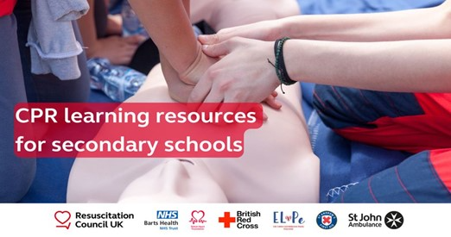

Resuscitation Council UK is the kitemark organisation for resuscitation in the UK. RCUK has worked with key partners to create resources webpage that will help teachers to deliver CPR education confidently to their students wherever they live in the UK at any time during the school year.

